Do use inheritance when one class is a more specific type of a superclass

DO NOT use inheritance just so that you can reuse
code from another class, and the relationship between the
superclass and subclass are not similar

DO NOT use inheritance if the subclass and superclass
do not pass the IS-A test,

Private instance and static variables cannot be overridden (although they can be redefined in the subclass, but that's not the same thing, and there's almost never a need to do it)

in what situation a class cannot be subclassed
1) when it is marked final
2) when all contructors of a class is private (java.lang.Math m = new java.lang.Math(); //can't do Math has private constructor)
3) when class is non-public it cannot be extended outside the package

Rules for Override
1) Arguments must be the same, and return types must be compatible.
2) The method can't be less accessible.

Interface : An 100% abstract class
Abstract Class: A class that cannot be instantiated. An abstract class has virtually* no use, no value, no purpose in life, unless it is extended.

Always the no arg constructor of super class is called from sub class constructor in the first line of sub class constructor,
if super(x,x) not provided manually.

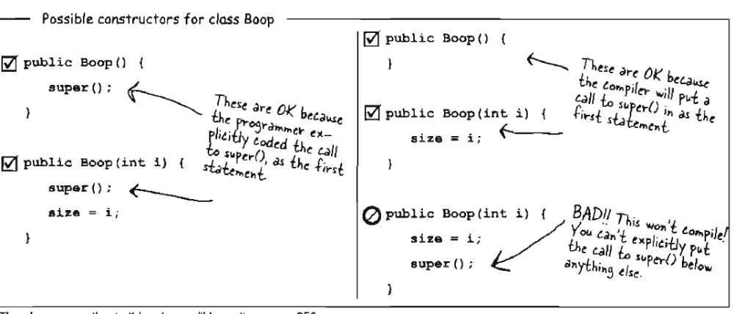

About this and super
1) Use this() to call a constructor from another overloaded constructor in the same class.
2) this() must be used only inside constructor and must be 1st line of constructor.
3) A constructor can have this() or super() in first line, but never both.

It is redundant to have to mark the methods final, If the class Is final. But allowed.

Static variable shares data across multiple objects. EX: Use static variable to get the count of object created.
Assigning a value to a final variable must be either at the time It Is declared, or in the constructor or in static block.-→if final variable not given default value, then compiler will throw error.

Question on AutoBoxing
1) List<int> intList = new ArrayList<int>(); // Error If autoboxing is not present
Autoboxing/Unboxing states that, compiler will do box/unbox, in place where primitive type is needed and object is provided… vice-versa.
- int i =10;
if (i instanceof Integer) //Error. Autoboxing will not work here. Reason not known
For Example:
List<Integer> intList = new ArrayList<Integer>();
int x = 10;
intList.add(x); // success. Here integer object is expected and we have given primitive so it converts.

String. format ("%tA, %<tB %<td " , new Date())
Prints : Wednesday, May 25

Question: An abstract class is useless unless it is extended. But How Calender is used still even though it is abstract class?
java.util.Calender is a abstract class. Has static variables and methods. Calling Calender.getInstance() returns an static Calender class with setting static variables like day,month etc.. based on locale.

Exception
Compiler ignores Subclass of RunTimeException and Error during compile and these can occur at runtime. RunTimeException(NullPointerException) can be caught but Error(OutOfMemoryError) will not be caught generally.
UnChecked Exception(subclass of RunTimeException),Checked Exceptions(All other than RunTimeException and Error)

Only static and transient variable are skipped during serialization.
If the class is serializable and that refers an object does not implements Serializable then serialization fails with java.io.NotSerializableException(RunTimeException)

Ques: Why would I ever write a class that wasn't serializable?
- security issue where you don't want a password object stored.
- Object depends on runtime entity like socket connections, threads etc…

Question: Does the constructor runs during deserialization? Ans:Yes and No.. For the reference variable which are serialized (non transient variable) constructor wont run. Because state of object that serialized will change if constructor runs. If subclass is serializable and parent class is not serializable, serializing on subclass will make the parent class as transient and during deserialization parent class constructor will run.

If a super class of the class Implements Serializable, the subclass will
automatically be serializable even If it does not specifically declare
implements Serializable.

Question: can u tell me why Object class doesn’t implement serializable.
if class Object is serializable then all the classes are serializable by default. So the Object doesn’t implements serializable.

You read objects (using readObject()) In the order In which they were originally written.

Most streams that can use a String filename can use a File object as well, and a File obiect
can be safer to use because it can verify file for its present, create, traverse and delete files.

InterruptedException.. Occurred when a thread is interrupted in sleeping..

If a class has many synchronized methods, and if 2 threads are created for a single object then only one thread can access any of one method at a time. Because the synchronized methods are locked based on object lock

Synchronization can leads to deadlock.

Collections.sort(userDefinedObject) -→ Error, if the userDefinedObject does not implement comparable and override compareTo

In generics, the "keyword" extends" really means is-a, and works for both classes and interfaces.
public <DE extends Comparable> void sort(ArrayList<DE> o)
DE is an userDefinedObject that implements Comparable and not extends Comparable

public final class String
extends Object
implements Serializable, Comparable<String>, CharSequence

public int compareTo(Song s) {
return title.compareTo(s.getTitle());
}

Song class implements Comparable. CompareTo with one argurment
Song class has 2 inner class that implements Comparator. Compare method that 2 argument
Advantages of Using comparator over comparable.
1) Sorting can be done on multiple attributes of class EX; Name, Age
What is the disadvantage of using comparable
1) for only one attributes of class, sort can be made

hashXXX uses index technique to fasten the search of element. The hashing algorithm may return same value for “baba” and “abba”. So to improve the correctness we first check for hashcode() and then equals()

If you declare a method to take ArrayList<Animal> it can take ONLY an
ArrayLisk<Animal>, not ArrayList<Dog> or ArragyList<Cat>.

But the array, Animal[] animals can take dog[], cat[] etc… because Array types are checked at runtime, but collection type checks happen only at compile time

ArrayList<? extends Parent> p = new ArrayList<Child>();
Child c = new Child(); //p is immutable, cannot add, only retrieve
//p.add(c); Error

This:
public <T extends Animal> void fun(ArrayList<T> list)
Does the same thing as this:
public void fun(ArrayList<? extends Animal> list)



String
StringBuffer-- synchronized
StringBuilder—similar to stringbuffer but not synchronized

To run assertion enabled code
java –ea MyClass --- if –ea is not given JVM runtime environment ignores statement with assert

